ECE 447
Lab 2 – Segment Counter
QUY PHAM
G00459909

- Introduction:
In this lab 2, everything will be almost the same as lab 1.We will be using MP430 microcontroller to implement a two-digit counter and display it on two 7-segments. There are two buttons to control the counter. Button SW1 is for enabling the counter. Button SW2 is for toggling the count up or count down. When the counter reaches the maximum or minimum, it will switch the counting state (if the counter is counting up, it will switch to count down). The only different is the code. Instead of using C to control the 7-segment display, we will use assembly language.
- Microcontroller Concepts:
The microcontroller on-chip peripherals which we use:
- 7 pins of port P2 (H4) to display number on the oneth-digit 7-segment.
- 7 pins of port P6 (H8) to display number on the tenth-digit 7-segment.
- The on board power to power the two 7-segment display and the two buffers.
- Hardware Design:
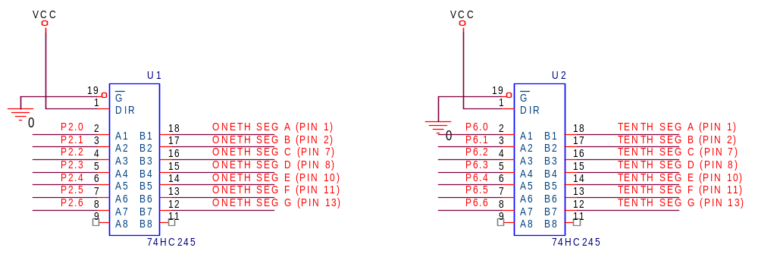

- Software Design:
Initialize counter with zero
Start
Interrupt occurs ?
Count up
Count down
Display on the segments
Yes
Yes
No
up
No
Enable btn pressed
Disable
SW1 or SW2 ?
Stop counter
SW1

Enable
SW2
Count up/dn Press ?
Count state ?

down

- Conclusion:
The lab result was what we expected. The counter worked and the numbers were shown correctly on the 7-segment displays. I encountered some problems when working with the simulation and the hardware part.
For the simulation part, I did not indicate stack in my code so later when my interrupt routine exited, it jumped to some weird location and crashed the program. To fix this, I use the default stack declare from the IRA tool.
For the hardware part, this was not really a problem. I calculated the resistor to control the current goes into the 7-segment display. It was 10Ω. But I had only one of those resistors in my kit so I had to borrow my friend’s before doing the demo.
- Questions:
- When interrupt is requested:
- Push PC on stack.
- Push SR on stack.
- If there are multiple interrupts occur, the high priority interrupt is selected.
- Clear SR to disable further maskable interrupts and terminate any low-power mode.
- Load interrupt vector into PC and start executing interrupt routine.
- “Maskable” interrupts are the interrupts that are only effective when the General Interrupt Enable (GIE) is set in Status Register (SR). They are ignored if the GIE is clear. The “non-maskable” interrupt does not depend on whether GIE is set or clear.
- The code-structure differences between the interrupt routine and a function is the keyword “RETI” for exiting the interrupt routine and the “RET” for exiting the function.

- Source code:
//constant and defines
WDTCTL EQU 0x0120
WDTSTP EQU 0x5A80
P1IN EQU 0x0020 // buttons/switches
P1DIR EQU 0x0022
P2IN EQU 0x0028
P2OUT EQU 0x0029
P2DIR EQU 0x002A
P6IN EQU 0x0034
P6OUT EQU 0x0035
P6DIR EQU 0x0036

PORT1_VECTOR EQU (20 * 2u)
RESET_VECTOR EQU (31 * 2u)
P1IE EQU 0x0025
P1IFG EQU 0x0023

BIT0 EQU 0x01
BIT1 EQU 0x02
BIT2 EQU 0x04
BIT3 EQU 0x08
BIT4 EQU 0x10
BIT5 EQU 0x20
BIT6 EQU 0x40
BIT7 EQU 0x80

// 7 segments
SEGA EQU BIT0
SEGB EQU BIT1
SEGC EQU BIT2
SEGD EQU BIT3
SEGE EQU BIT4
SEGF EQU BIT5
SEGG EQU BIT6
// numbers from 0-15
//-AA-
//F B
//-GG-
//E C
//-DD-
NUM0 EQU SEGA|SEGB|SEGC|SEGD|SEGE|SEGF//SEGA+SEGB+SEGC+SEGD+SEGE+SEGF
NUM1 EQU SEGB|SEGC//SEGB+SEGC
NUM2 EQU SEGA|SEGB|SEGD|SEGE|SEGG//SEGA+SEGB+SEGD+SEGE+SEGG
NUM3 EQU SEGA|SEGB|SEGC|SEGD|SEGG//SEGA+SEGB+SEGC+SEGD+SEGG
NUM4 EQU SEGB|SEGC|SEGF|SEGG//SEGB+SEGC+SEGF+SEGG
NUM5 EQU SEGA|SEGC|SEGD|SEGF|SEGG//SEGA+SEGC+SEGD+SEGF+SEGG
NUM6 EQU SEGA|SEGC|SEGD|SEGE|SEGF|SEGG//SEGA+SEGC+SEGD+SEGE+SEGF+SEGG
NUM7 EQU SEGA|SEGB|SEGC//SEGA+SEGB+SEGC
NUM8 EQU SEGA|SEGB|SEGC|SEGD|SEGE|SEGF|SEGG//SEGA+SEGB+SEGC+SEGD+SEGE+SEGF+SEGG
NUM9 EQU SEGA|SEGB|SEGC|SEGD|SEGF|SEGG//SEGA+SEGB+SEGC+SEGD+SEGF+SEGG
NUMA EQU SEGA|SEGB|SEGC|SEGE|SEGF|SEGG//SEGA+SEGB+SEGC+SEGE+SEGF+SEGG
NUMB EQU SEGC|SEGD|SEGE|SEGF|SEGG
NUMC EQU SEGA|SEGD|SEGE|SEGF
NUMD EQU SEGB|SEGC|SEGD|SEGE|SEGG
NUME EQU SEGA|SEGD|SEGE|SEGF|SEGG
NUMF EQU SEGA|SEGE|SEGF|SEGG

DELAY_FACTOR EQU 0xFFFF
DELAY_SEC EQU 1
COUNT_MIN EQU 0
COUNT_MAX EQU 0xFF
TRUE EQU 0xFF
FALSE EQU 0

NAME main ; module name

PUBLIC main ; make the main label vissible
; outside this module
ORG 0FFFEh
DC16 init ; set reset vector to 'init' label

RSEG CSTACK ; pre-declaration of segment

RSEG CODE ; place program in 'CODE' segment

init: MOV #SFE(CSTACK), SP ; set up stack

main: ; main program
MOV.W #WDTSTP,&WDTCTL
MOV.B #0,&P1DIR
MOV.B #0x7F,&P2DIR
MOV.B #0x7F,&P6DIR

MOV.B #COUNT_MIN,&count
MOV.B #FALSE,&CountEn
MOV.B #TRUE,&CountUpFlag

BIS.B #BIT0|BIT1,&P1IE
EINT

LOOP:
CMP.B #TRUE,&CountEn
JNZ DISPLAY_NUM ;COUNT_NOT_EN
CMP.B #TRUE,&CountUpFlag
JNZ COUNT_DOWN
;COUNT_UP:
MOV.B &count,R4
CMP.B #COUNT_MAX,R4
JHS UP2DOWN
INC.B &count
JMP DISPLAY_NUM
UP2DOWN:
DEC.B &count
MOV.B #FALSE,&CountUpFlag
JMP DISPLAY_NUM
COUNT_DOWN:
MOV #COUNT_MIN,R4
CMP.B &count,R4
JHS DOWN2UP
DEC.B &count
JMP DISPLAY_NUM
DOWN2UP:
INC.B &count
MOV.B #TRUE,&CountUpFlag

DISPLAY_NUM:
XOR R4,R4
XOR R5,R5
MOV.B &count,R4
AND.B #0x0F,R4
ADD #nums,R4
MOV.B 0(R4),R5
INV.B R5
MOV.B R5,&P2OUT

XOR R4,R4
XOR R5,R5
MOV.B &count,R4
AND.B #0xF0,R4
RRA.B R4
RRA.B R4
RRA.B R4
RRA.B R4
AND.B #01111111b,R4
ADD #nums,R4
MOV.B 0(R4),R5
INV.B R5
MOV.B R5,&P6OUT

INIT_DELAY:
MOV #0,R4
MOV #DELAY_SEC,R5
DELAY_LOOP:
CMP.W #DELAY_FACTOR,R4
JZ CHECK_SEC
INC R4
JMP DELAY_LOOP
CHECK_SEC:
CMP.B #0,R5
JZ LOOP
DEC.B R5
JMP DELAY_LOOP

;------------------------------------------------
BTNPUSH_ISR:
BIT.B #BIT0,&P1IFG
JNZ EN_BTN
BIT.B #BIT1,&P1IFG
JNZ SWITCH_COUNT
JMP RESET_IF
EN_BTN:
INV.B &CountEn
JMP RESET_IF
SWITCH_COUNT:
INV.B &CountUpFlag
RESET_IF:
BIC.B #BIT0|BIT1,&P1IFG
RETI
;------------------------------------------------
RSEG DATA16_C
nums DB NUM0,NUM1,NUM2,NUM3,NUM4,NUM5,NUM6,NUM7,NUM8,NUM9,NUMA,NUMB,NUMC,NUMD,NUME,NUMF
;------------------------------------------------
RSEG DATA16_N
count DS 1
CountEn DS 1
CountUpFlag DS 1
;------------------------------------------------
COMMON INTVEC
ORG PORT1_VECTOR
DW BTNPUSH_ISR
END

